**IT ERA FINALS**

The Internet is a global web of computers connected to each other by wires, (mostly phone lines). If you look at a map of big cities, smaller towns, and scattered houses, each is connected together with roads, railways, etc. This is similar to the Internet, except with the Internet, wires connect computers. The Internet is a superhighway.

Some ways to use the Internet: E-mail, Research, Shopping, News, Games, Ed-line.

Internet Terms – WWW, Browser, Search Engine, URL, Domain, html.

* The World Wide Web (short for Web) is a system of interlinked hypertext documents accessed via the Internet. The World Wide Web was created in 1989 by English scientist Tim Berners-Lee, working at the European Organization for Nuclear Research (CERN) in Geneva, Switzerland, and released in 1992.
* Browser - Software program that allows a person to view WWW documents. Examples of browsers are Netscape, Microsoft Internet Explorer, Mosaic, Mac web, and Net cruiser.
* Search Engine - A web site that will help you search the Internet for key words, subjects, etc. A search engine is an information retrieval system designed to help find information stored on a computer system. Web search engines provide an interface to search for information on the World Wide Web. Information may consist of web pages, images and other types of files.
* The very first tool used for searching on the (pre-web) Internet was Archie. It was created in 1990 by Alan Emtage.
* The first Web search engine was Wandex, developed by Matthew Gray at MIT in 1993.
* Aliweb also appeared in 1993 but released in early 1994. Used a crawler to find web pages for searching, but search was limited to the title of web pages only.

One of the first "full text" crawler-based search engines was WebCrawler, which came out in 1994.

Also in 1994 Lycos (which started at Carnegie Mellon University) was launched, and became a major commercial endeavor.

* Google search - Web search engine owned by Google, Inc. Google search was originally developed by Larry Page and Sergey Brin in 1997.
* Yahoo! Search - The two founders of Yahoo!, David Filo and Jerry Yang, Ph.D. candidates in Electrical Engineering at Stanford University.
* MSN Search - The most recent major search engine evolved into Live Search, owned by Microsoft.

Examples of search engines:

1. Google: Google is the most widely used search engine globally. It offers a simple interface and provides relevant search results based on user queries.
2. Bing: Bing is a search engine developed by Microsoft. It provides web search, image search, video search, and map search, among other features.
3. Yahoo: Yahoo Search is another popular search engine that provides search services, including web, image, and video search.
4. Baidu: Baidu is the most popular search engine in China and offers similar services to Google, including web search, image search, and multimedia content search.
5. Yandex: Yandex is a Russian search engine that offers various services, including web search, image search, video search, and map services.
6. DuckDuckGo: DuckDuckGo is known for its privacy-focused search capabilities. It does not track users or store their personal information, making it a popular choice for those concerned about online privacy.
7. Ask.com: Ask.com, previously known as Ask Jeeves, is a question-answering-focused search engine. It allows users to ask questions in natural language and provides relevant answers.
8. AOL Search: AOL Search is a search engine provided by AOL that offers web search, image search, and video search.

URL – (UNIFORM RESOURCE LOCATOR) The unique address of any web page. It tells your computer where the information is stored so it can be viewed.

Domain - A way to indicate what type of site you may be viewing. In the U.S. some common domains are .com-commercial, .org- non-profit and research organizations, .gov- government agency, .edu-education. More are constantly being added so these should only be used as guidelines to help you know what type of site you are on.

Domain Name - The following example illustrates the difference between a URL (Uniform Resource Locator) and a domain name: URL: http://www.example.net

Domain name: www.example.net

Registered domain name: example.net,

Top level Domain: The last part of an Internet domain name; that is, the letters that follow the final dot of any domain name.

www.example.com - Com is the top level domain

Groups of top level domain

1. infrastructure top-level domain: This group consists of one TLD, the Address and Routing Parameter Area (ARPA). Arpa
2. country-code top-level domains (ccTLD): Used by a country or a dependent territory. It is two letters long. .ph – Philippines .au- Australia .us-United States .ar – Argentina .gu-Guam
3. Sponsored top-level domains (sTLD): These domains are proposed and sponsored by private agencies or organizations that establish and enforce rules restricting the eligibility to use the TLD. .edu – Education .gov – Government .mil – Military .int - International Treaties .asia - Companies, organizations and individuals in the Asia-Pacific region
4. Generic top-level domains (gTLD): Generic domains are essentially open for registration to anyone in the world. .com - Commercial organization .info - Informational sites .net - Network infrastructures .org – Organizations
5. Generic-restricted top level domains. Registrations within them are supposed to require proof of eligibility within the guidelines set for each. .biz - Business use .pro – Profession .name - Families and individuals

Second-level domain (SLD) - Second-level domains commonly refer to the organization that registered the domain name with a domain name registrar. For example, in wikipedia.org, wikipedia is the second-level domain of the .org TLD.

Some domain name registries introduce a second-level hierarchy to a TLD that indicates the type of organization intended to register an SLD under it. For example: www.spusurigao.edu.ph

Surigao - SLD .ph – TLD .edu - second level hierarchy of TLD

Basic Structure of HTML

* HTML is a language for describing web pages.
* HTML stands for Hyper Text Markup Language
* HTML is not a programming language, it is a markup language
* A markup language is a set of markup tags
* HTML uses markup tags to describe web pages

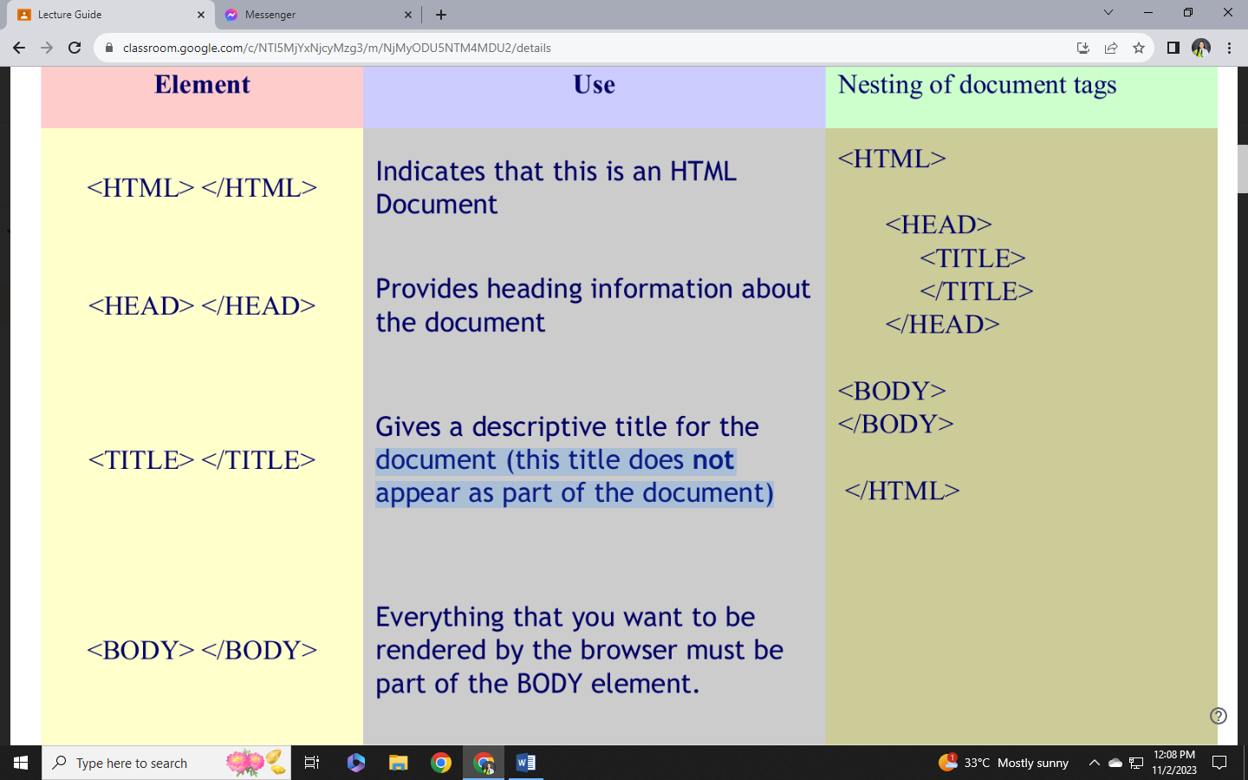HTML Tags

* HTML markup tags are usually called HTML tags
* HTML tags are keywords surrounded by angle brackets like <html>
* HTML tags normally come in pairs like <b> and </b>
* The first tag in a pair is the start tag, the second tag is the end tag
* Start and end tags are also called opening tags and closing tags.

To identify an HTML document that the browser should display:

Example 1

<html>

<body>

<h1>My First Heading</h1>

<p>My first paragraph</p>

</body>

</html>

* 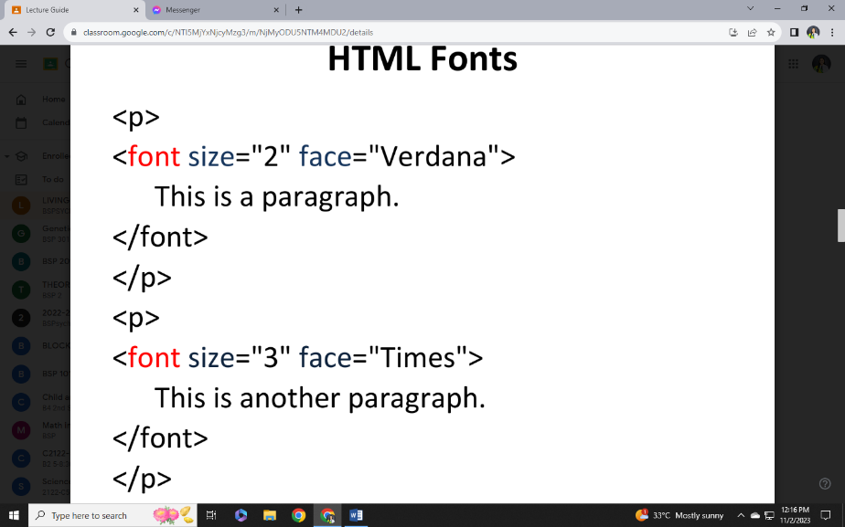The text between <html> and </html> describes the web page
* The text between <body> and </body> is the visible page content
* The text between <h1> and </h1> is displayed as a heading
* The text between <p> and </p> is displayed as a paragraph\

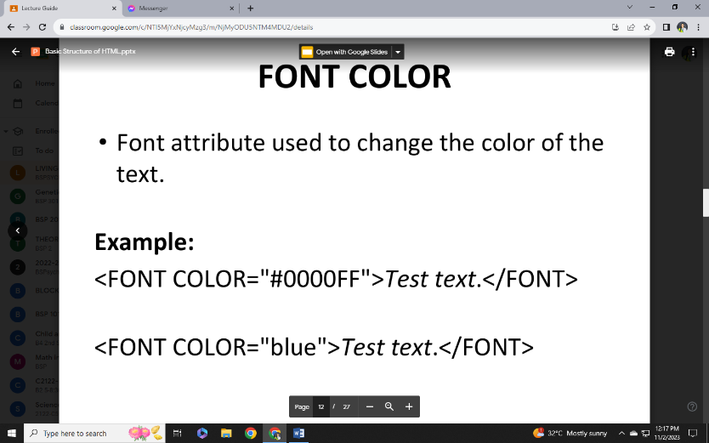HTML headings are defined with the <h1> to <h6> tags.

HTML paragraphs are defined with the <p> tag.

.HTM or .HTML File Extension?

When you save an HTML file, you can use either the .htm or the .html file extension. There is no difference, it is entirely up to you.

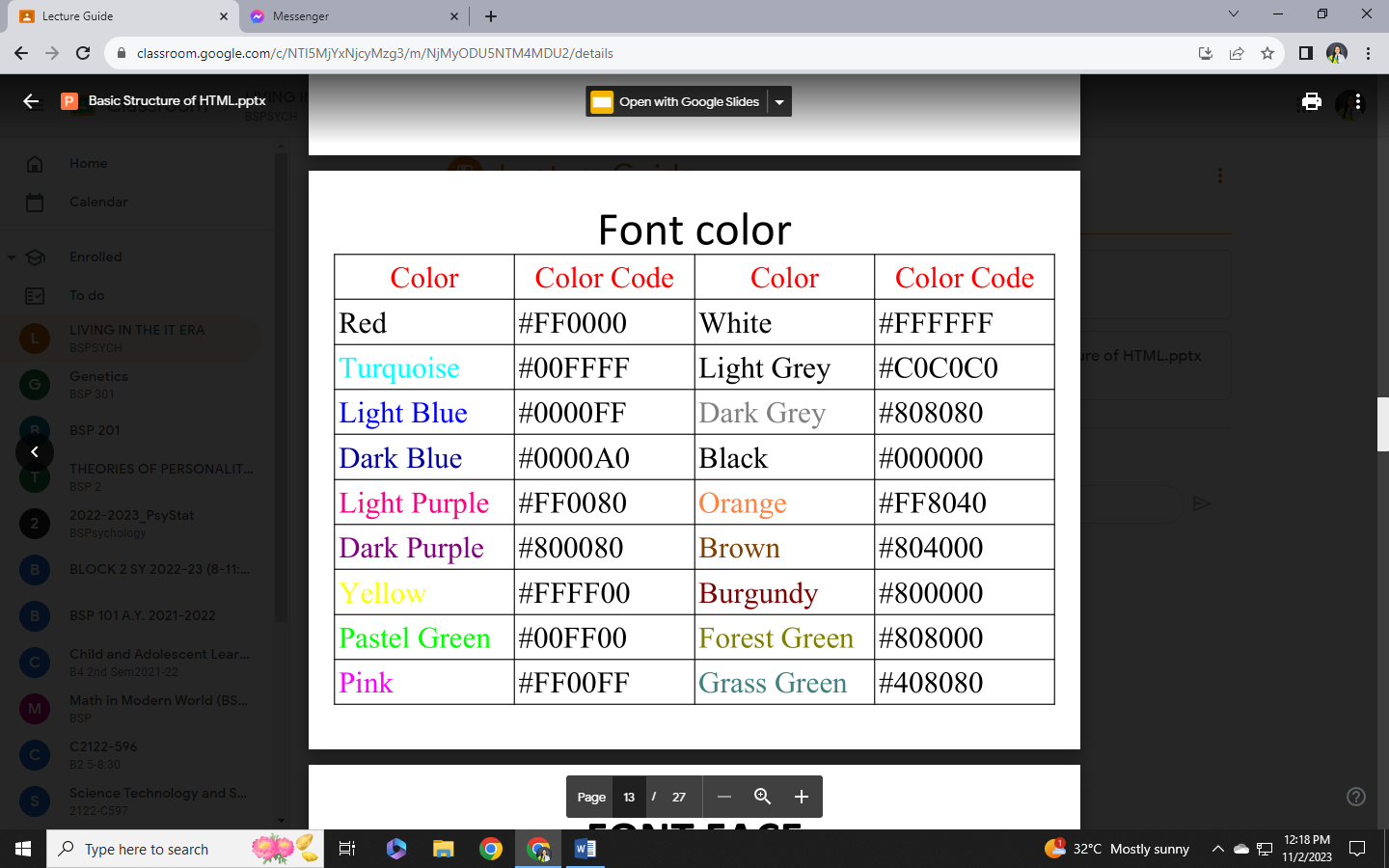How to start typing the HTML doc.?

* Click Programs
* Click Accessories
* Click Notepad
* Type the HTML program

Heading, Paragraph, Line Break

* To insert a heading to your document type it in the body section

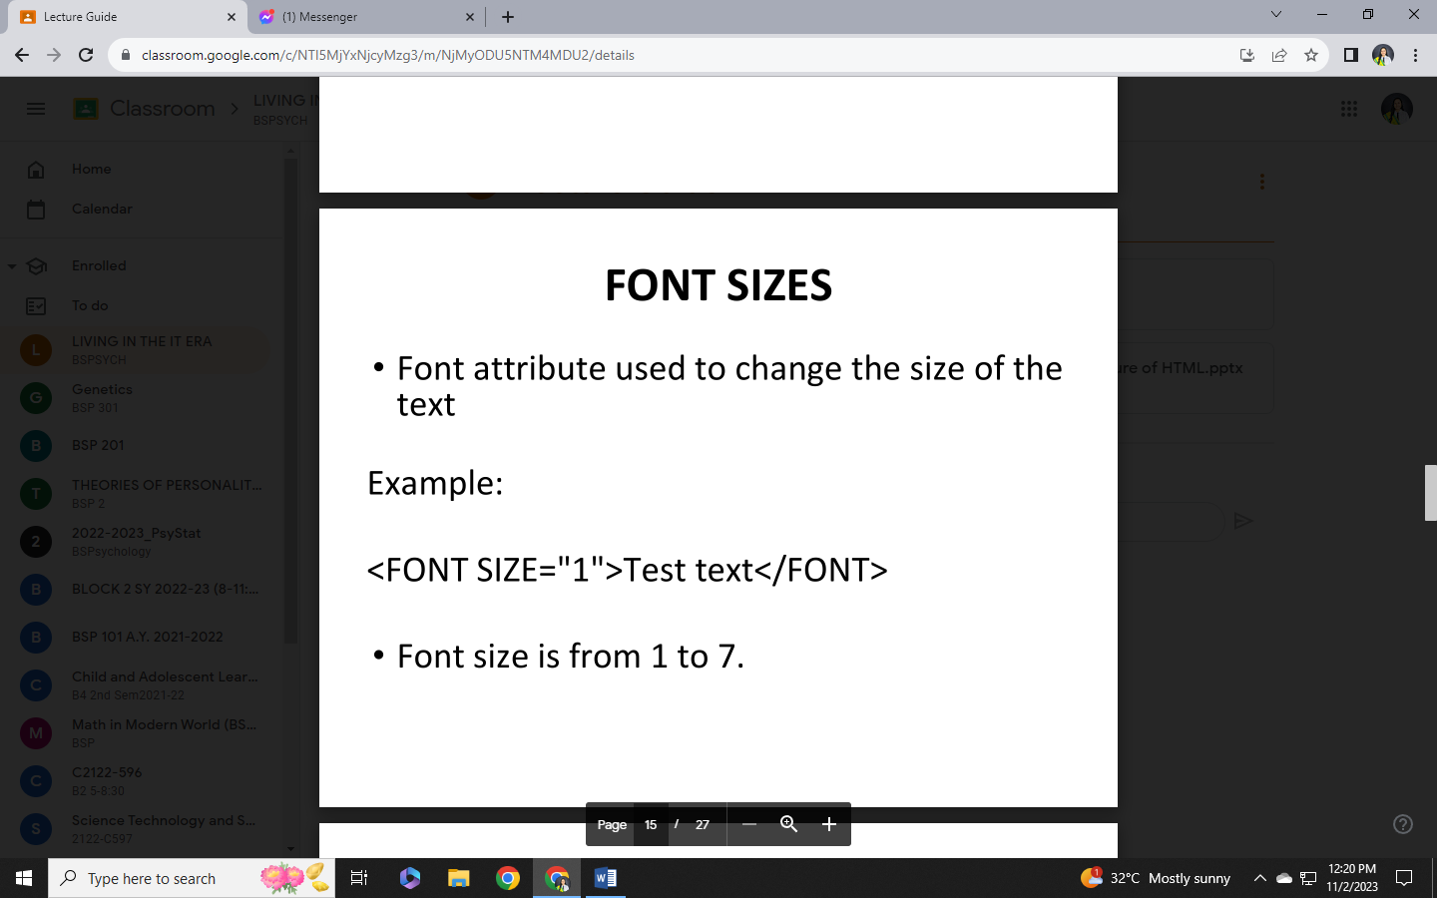<h1></h1>

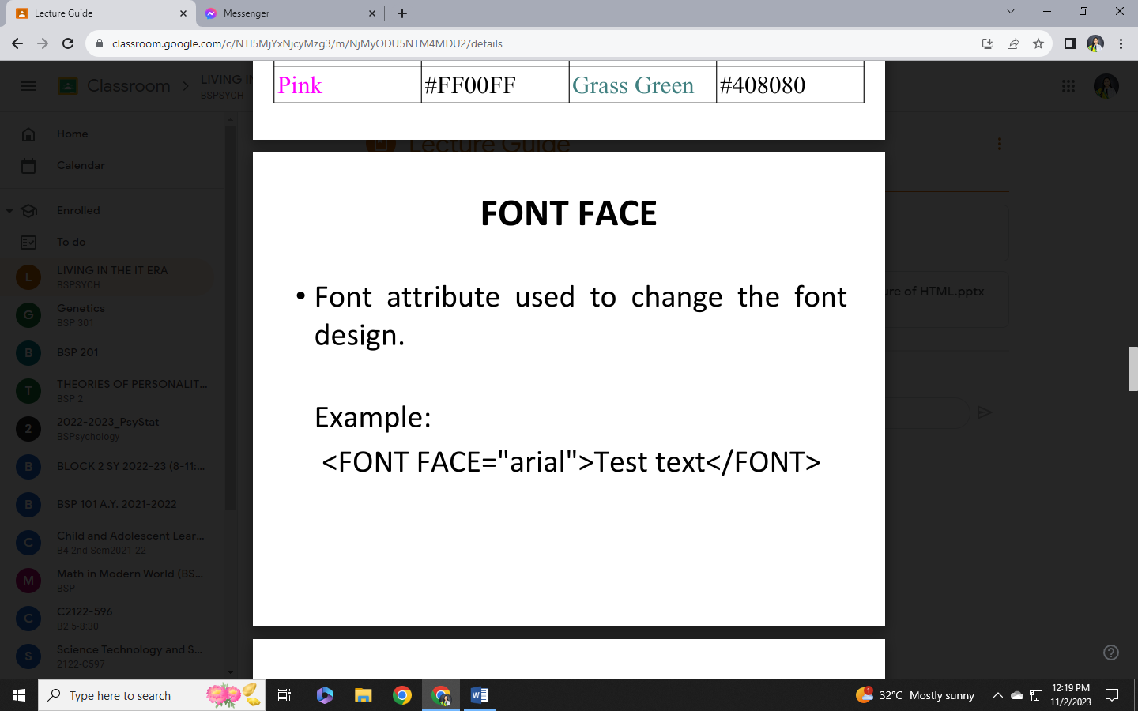<h2></h2>

<h3></h3>

<h4></h4>

<h5></h5>

<h6> </h6>

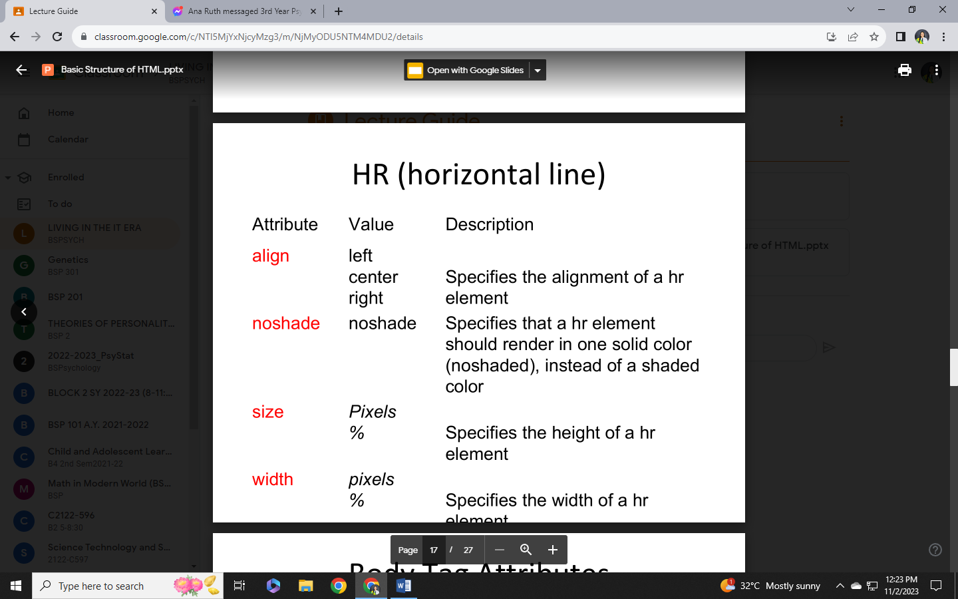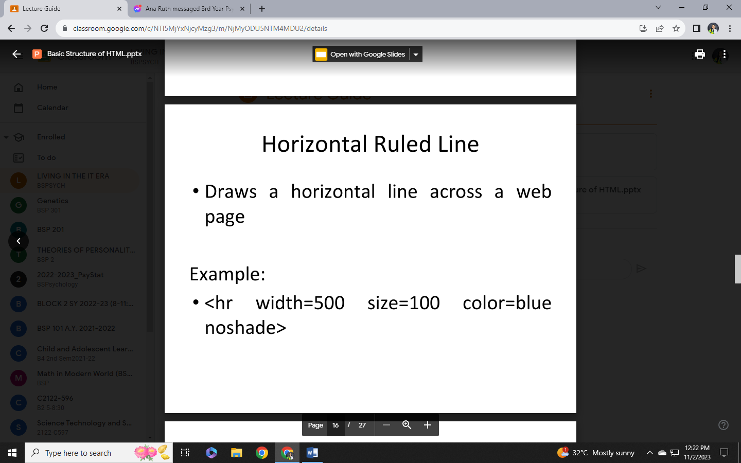<p> - Defines a paragraph

<br /> - Inserts a single line break

Body Tag Attributes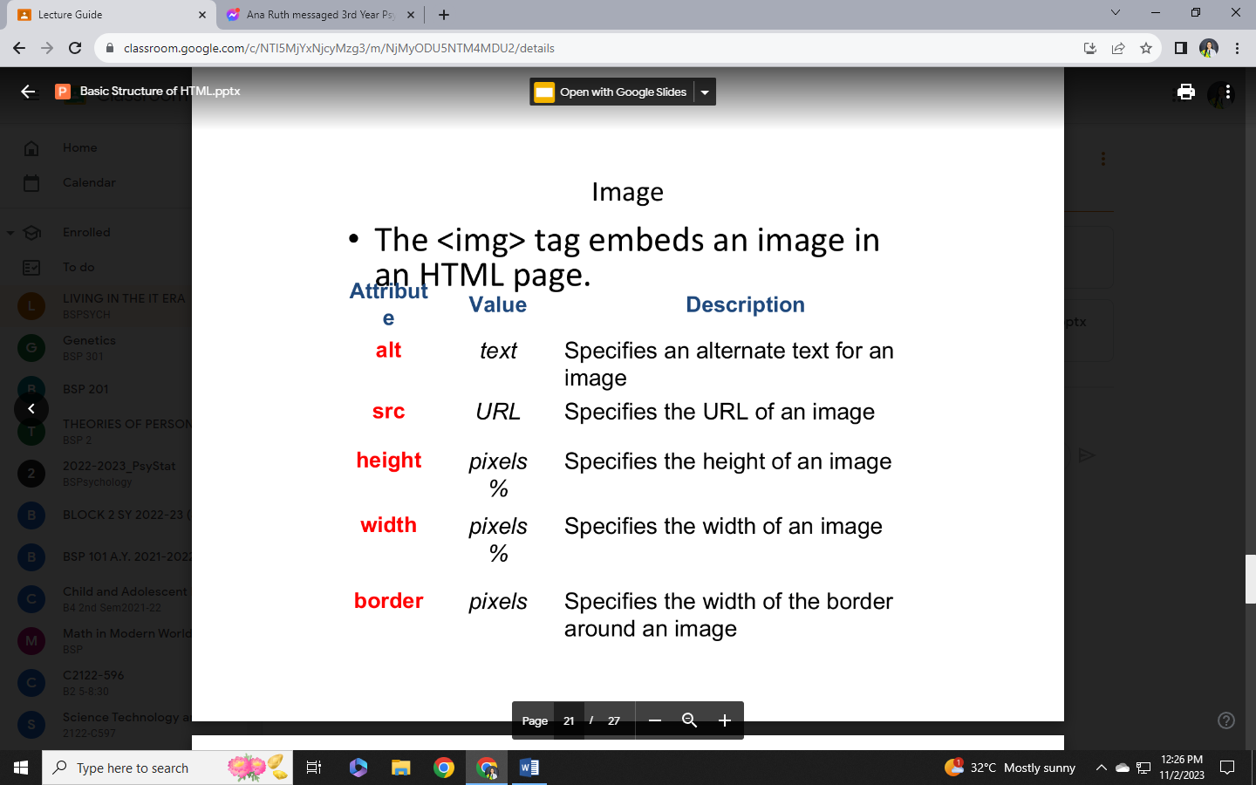

* BACKGROUND - identifies an image file that will be tiled to form the background for the page
* TEXT - specifies a color for normal text
* BGCOLOR - Specifies a color for the page background (will not appear if the BACKGROUND attribute is also used)
* Color Background –

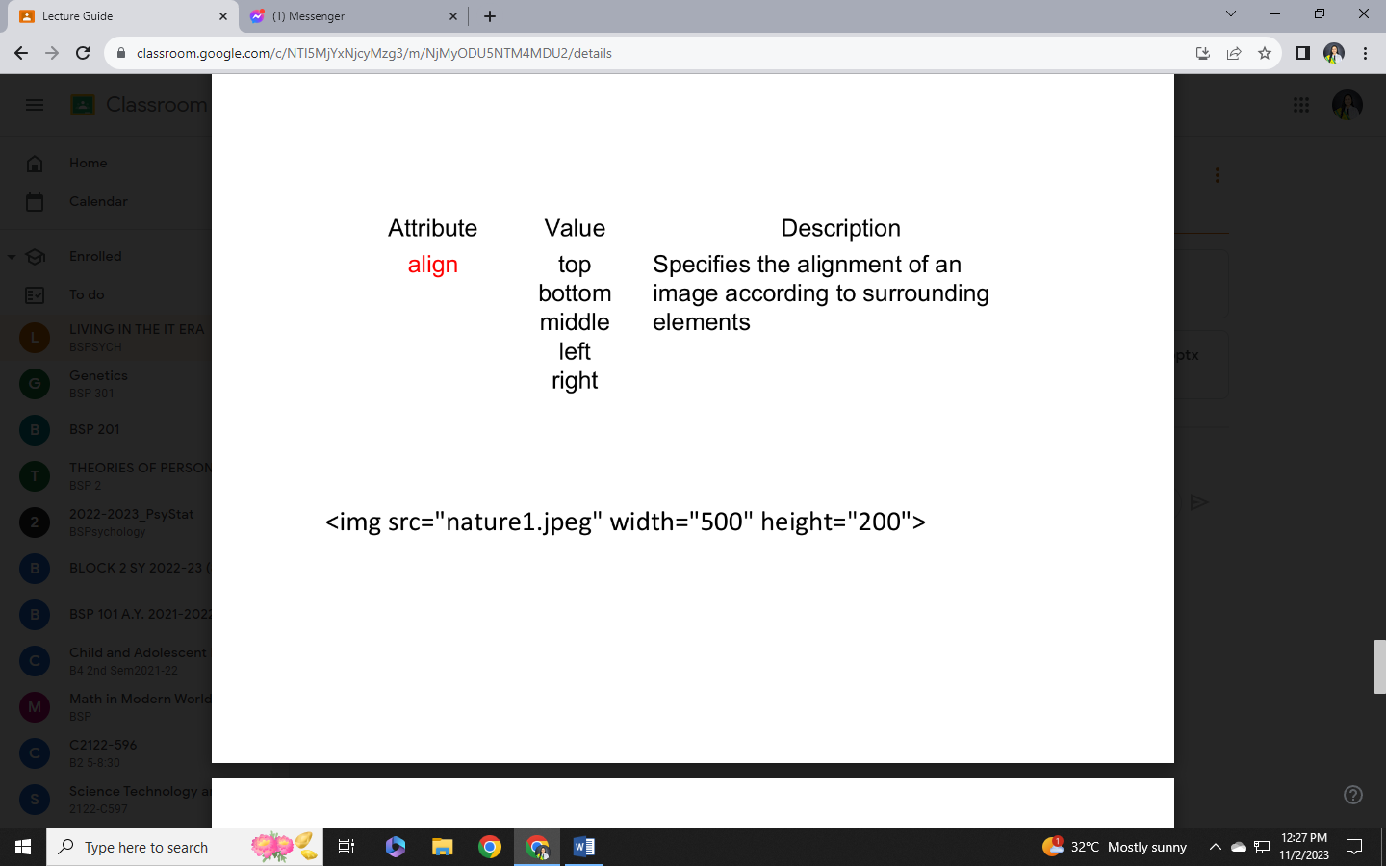 <html>  
<body bgcolor=“yellow">

</body>

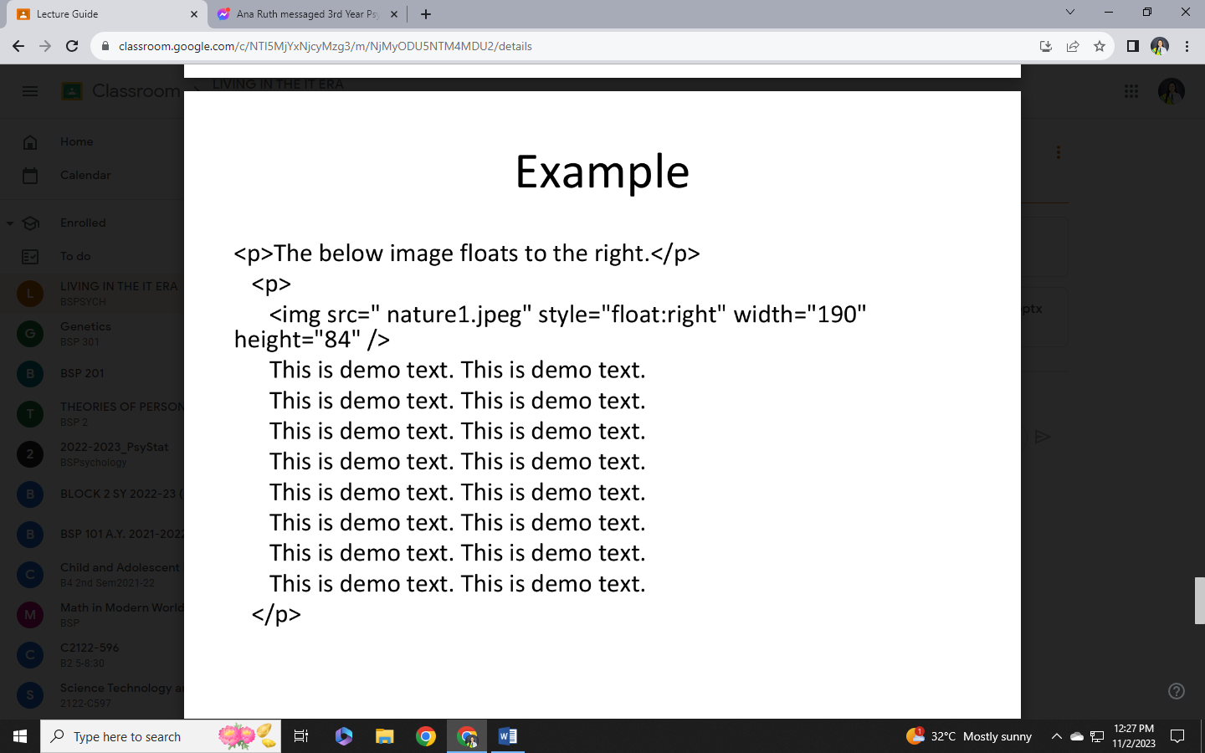</html>

* **BACKGROUND IMAGE**

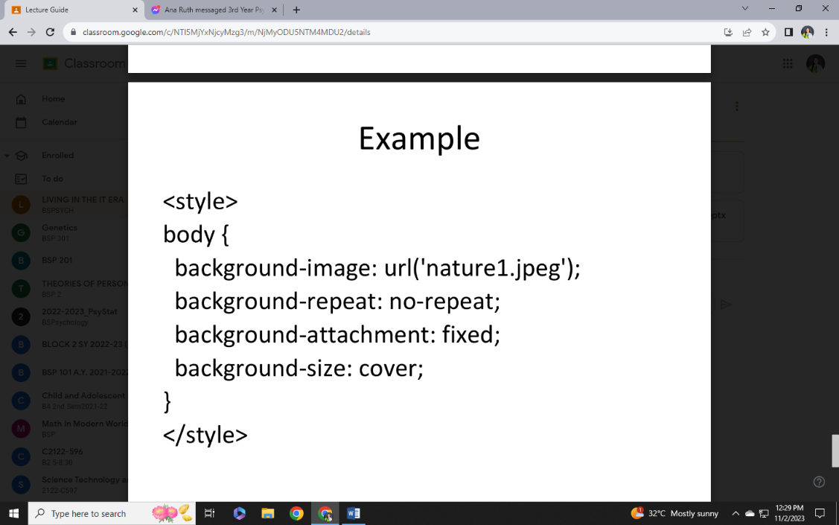< body background=“nature1.jpeg”>

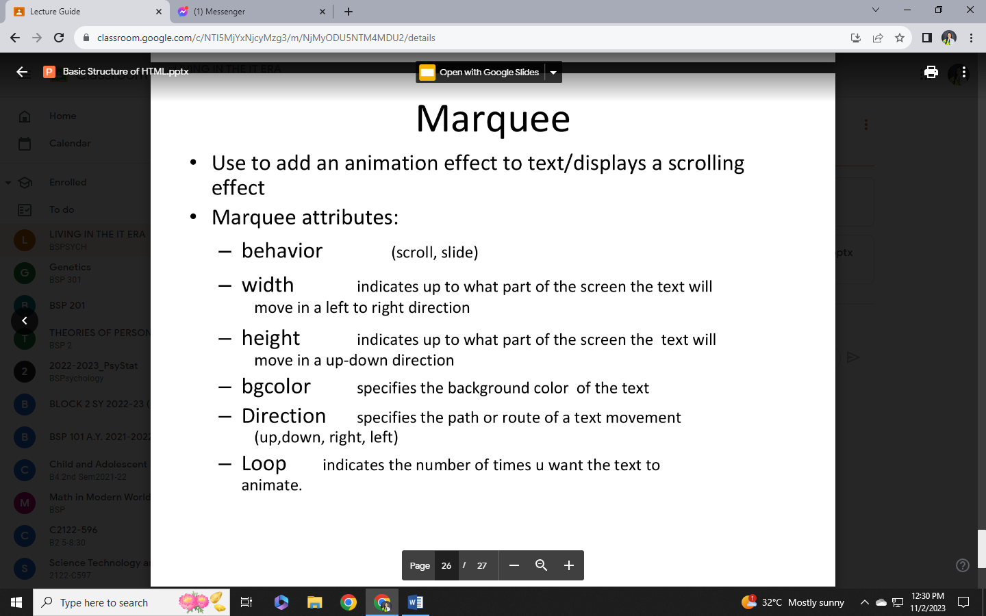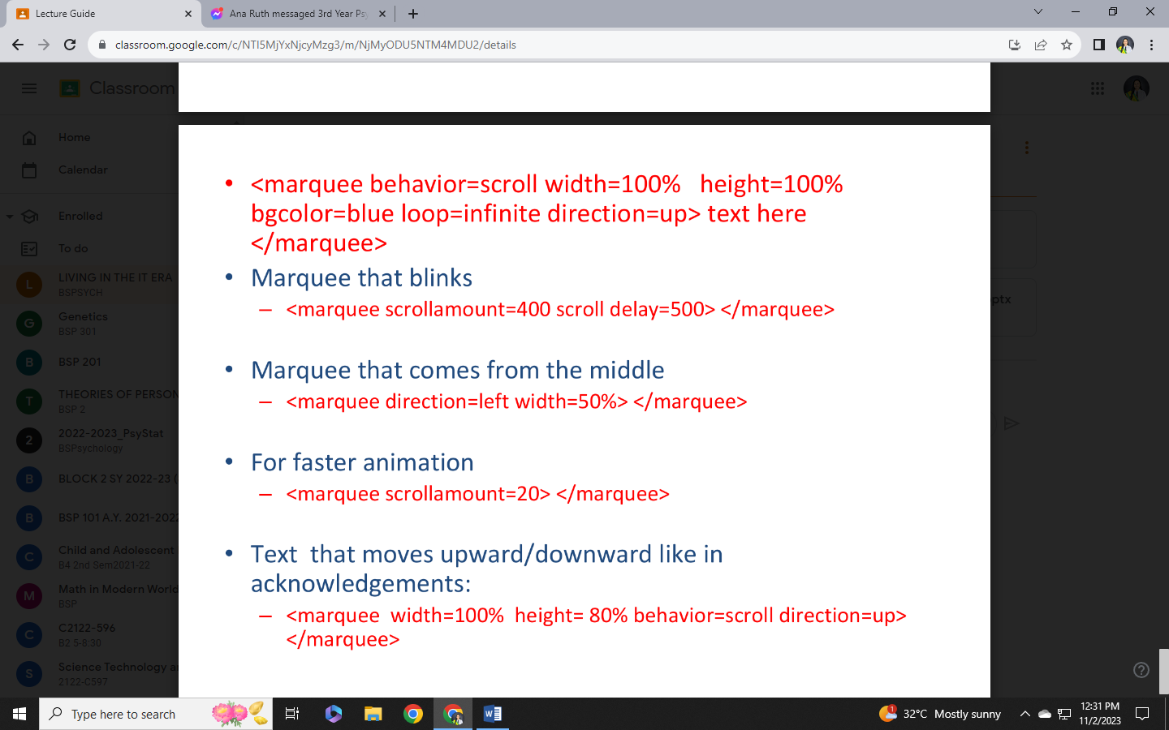

LINKS

* 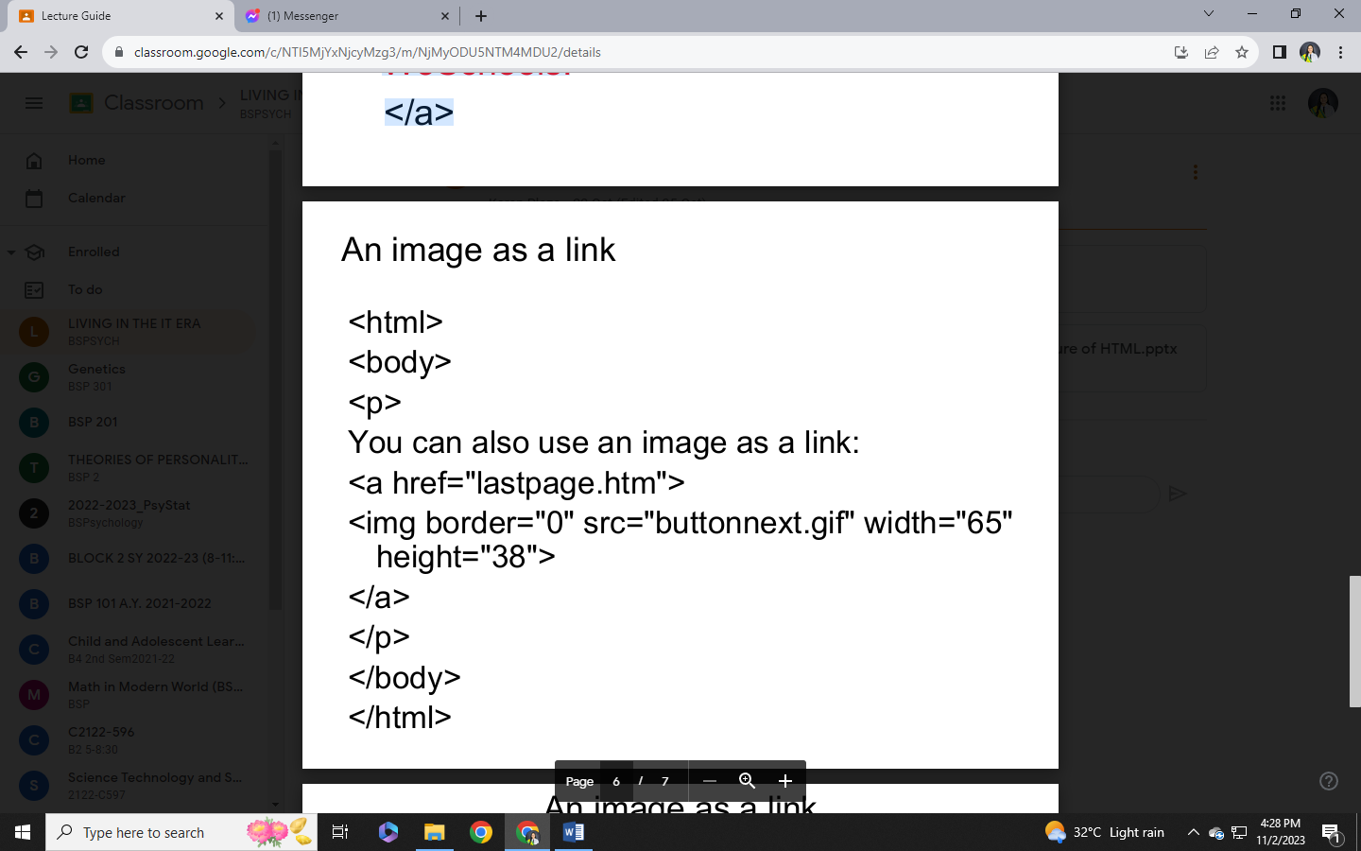Hyperlinks can point to any resource on the web: an HTML page, an image etc. An anchor is a term used to define a hyperlink destination inside a document. The HTML anchor element <a>, is used to define both hyperlinks and anchors. <a href="url">Link text</a>
* The <a> tag defines an anchor. An anchor can be used in two ways: To create a link to another document, by using the href attribute. To create a bookmark inside a document, by using the name attribute. By default, links will appear as follows in all browsers: An unvisited link is underlined and blue. A visited link is underlined and purple.
* href attribute - The href attribute defines the link "address".

<a href="http://www.w3schools.com/">VisitW3Schools!</a>

* 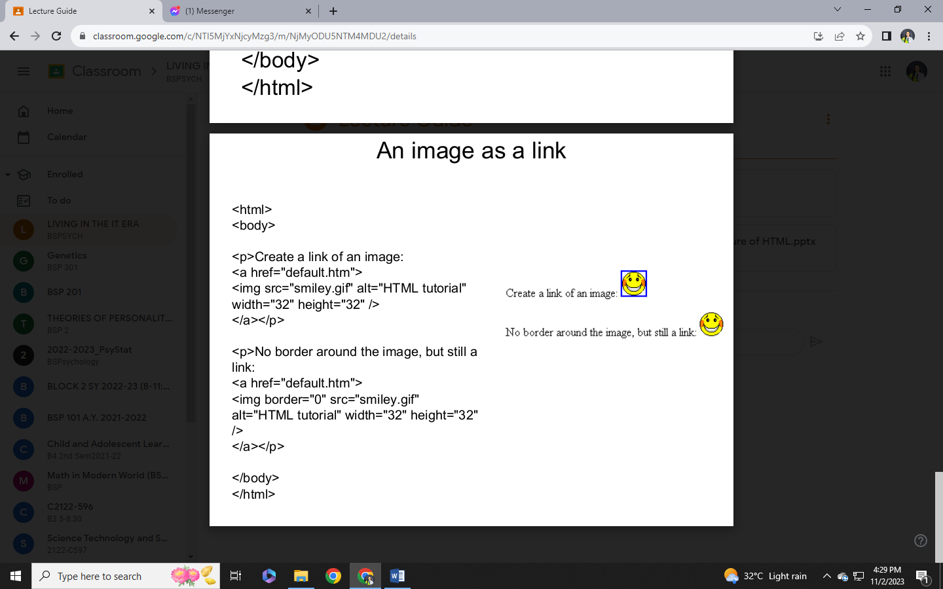Tables are defined with the <table> tag. Table is divided into rows (with the <tr> tag), and each row is divided into data cells (with the <td> tag). The letters td stands for "table data," which is the content of a data cell.

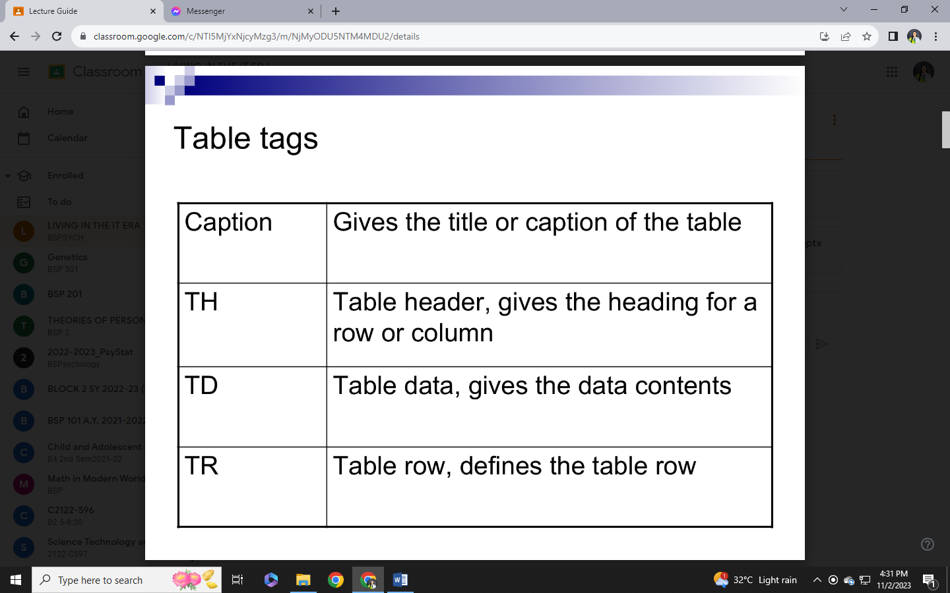

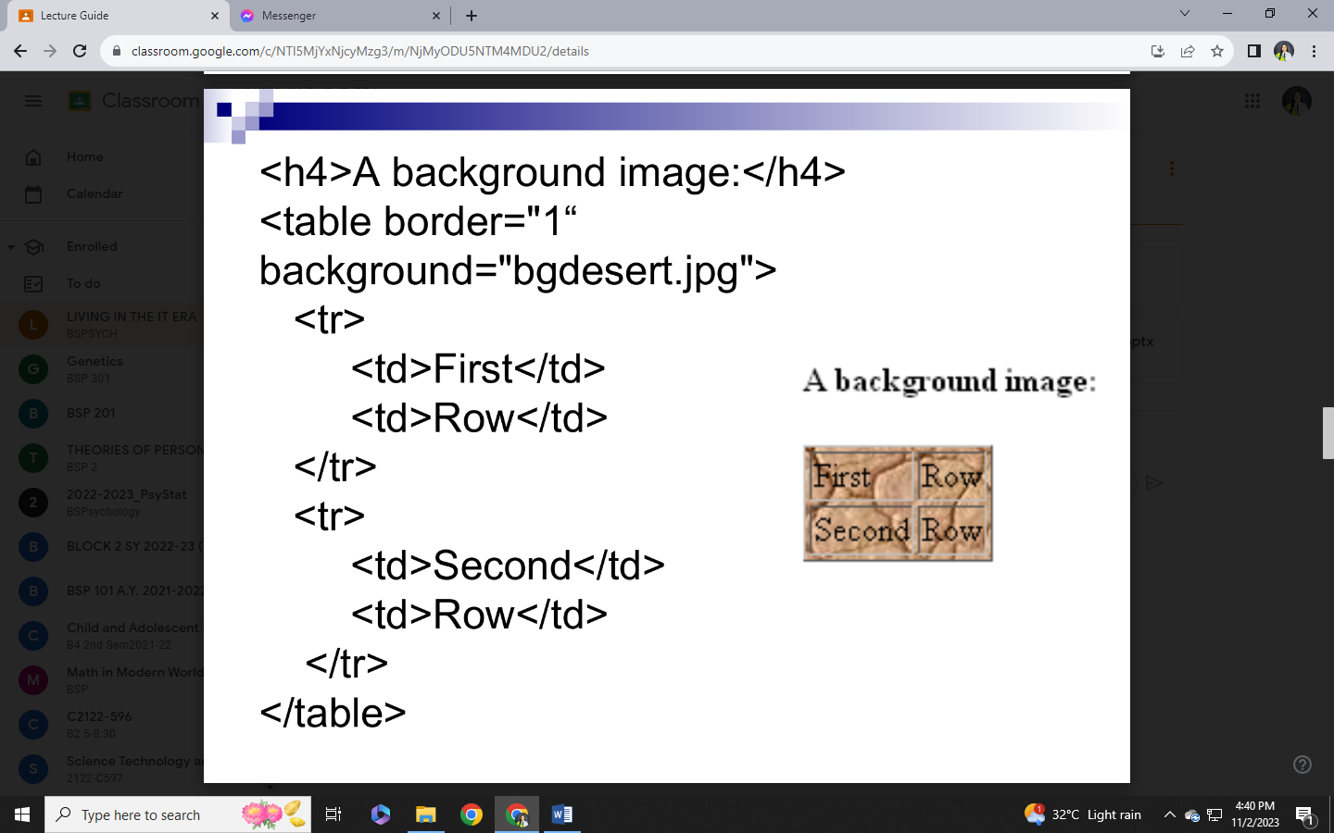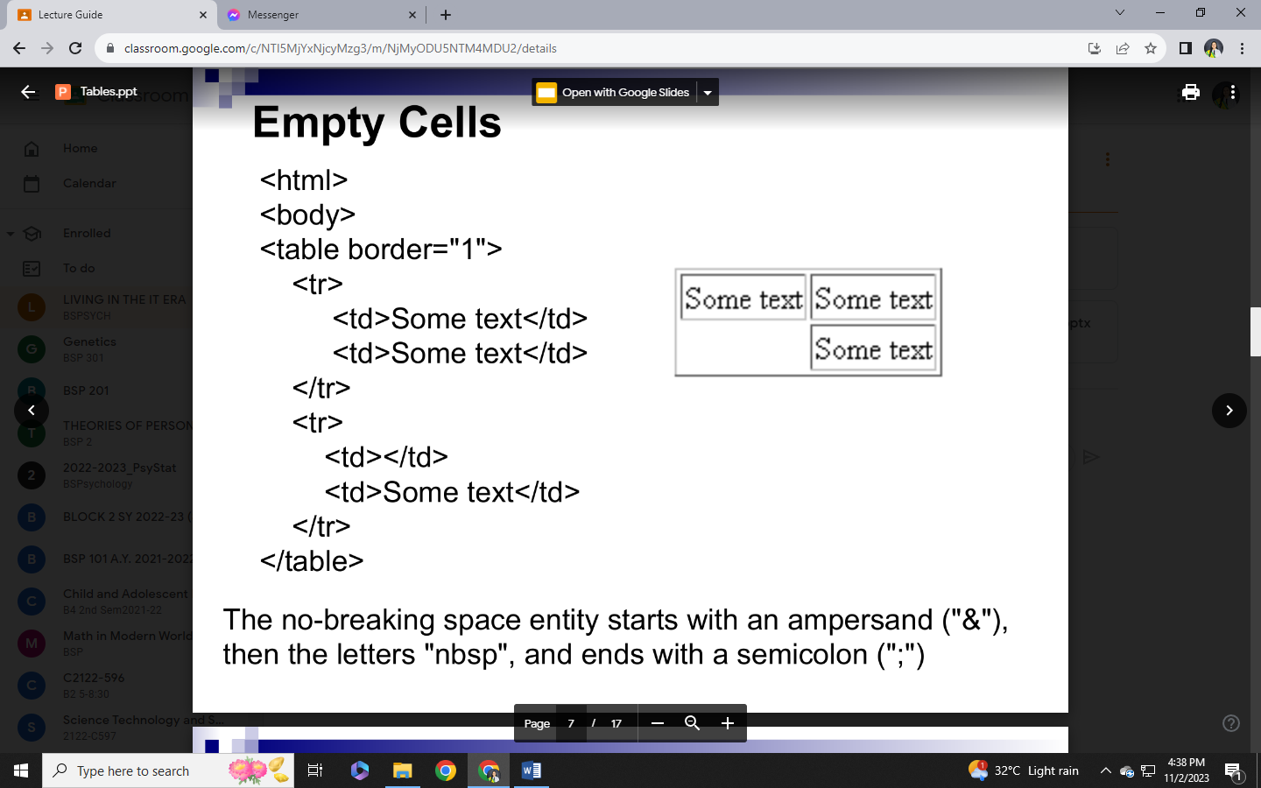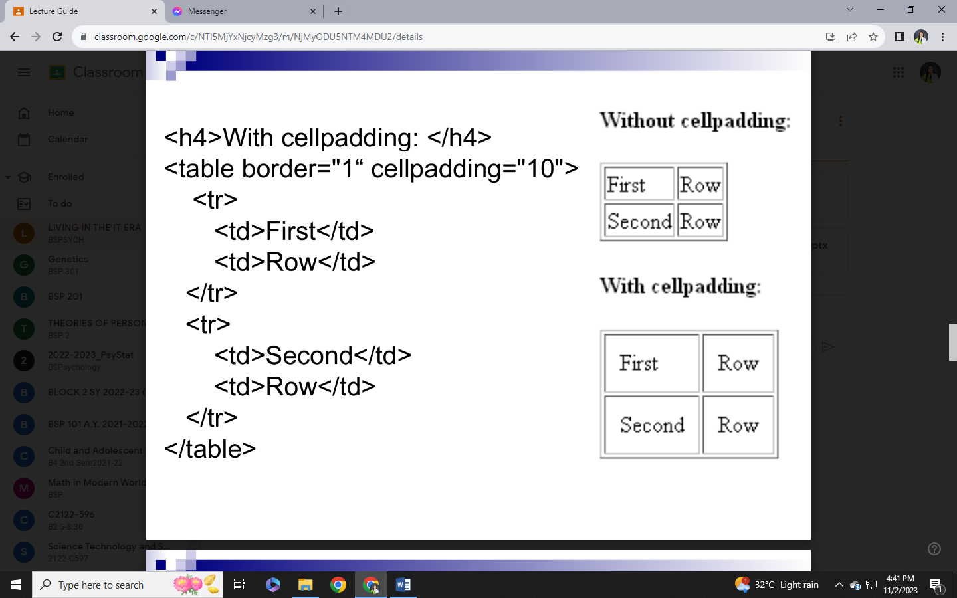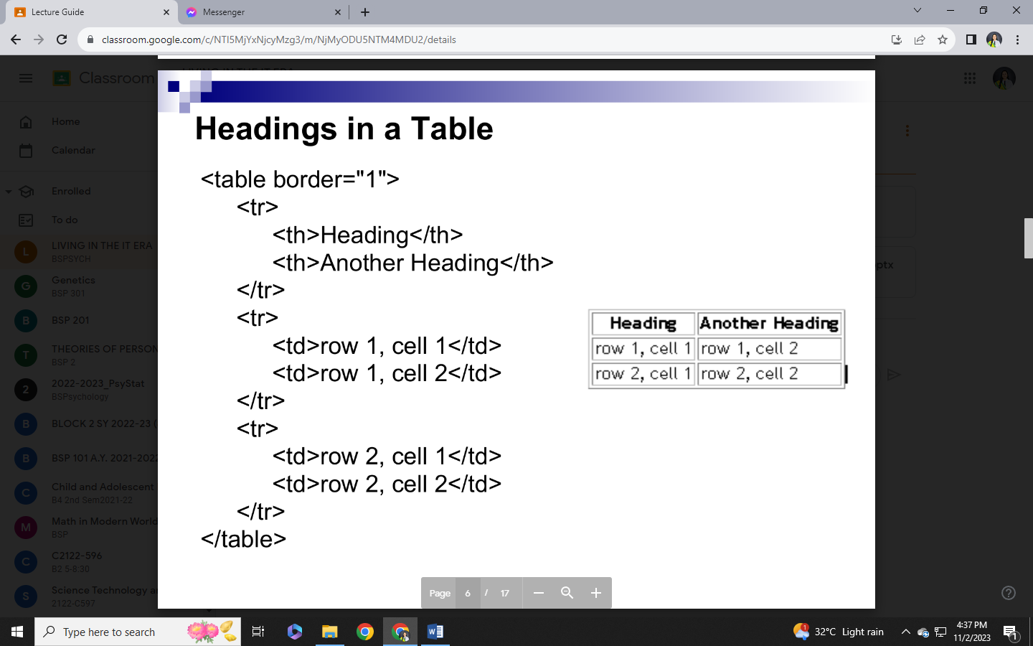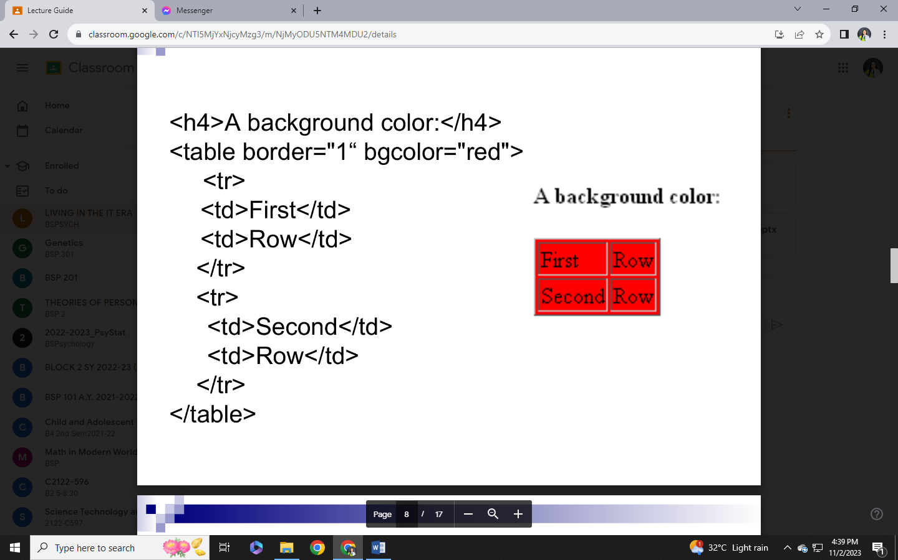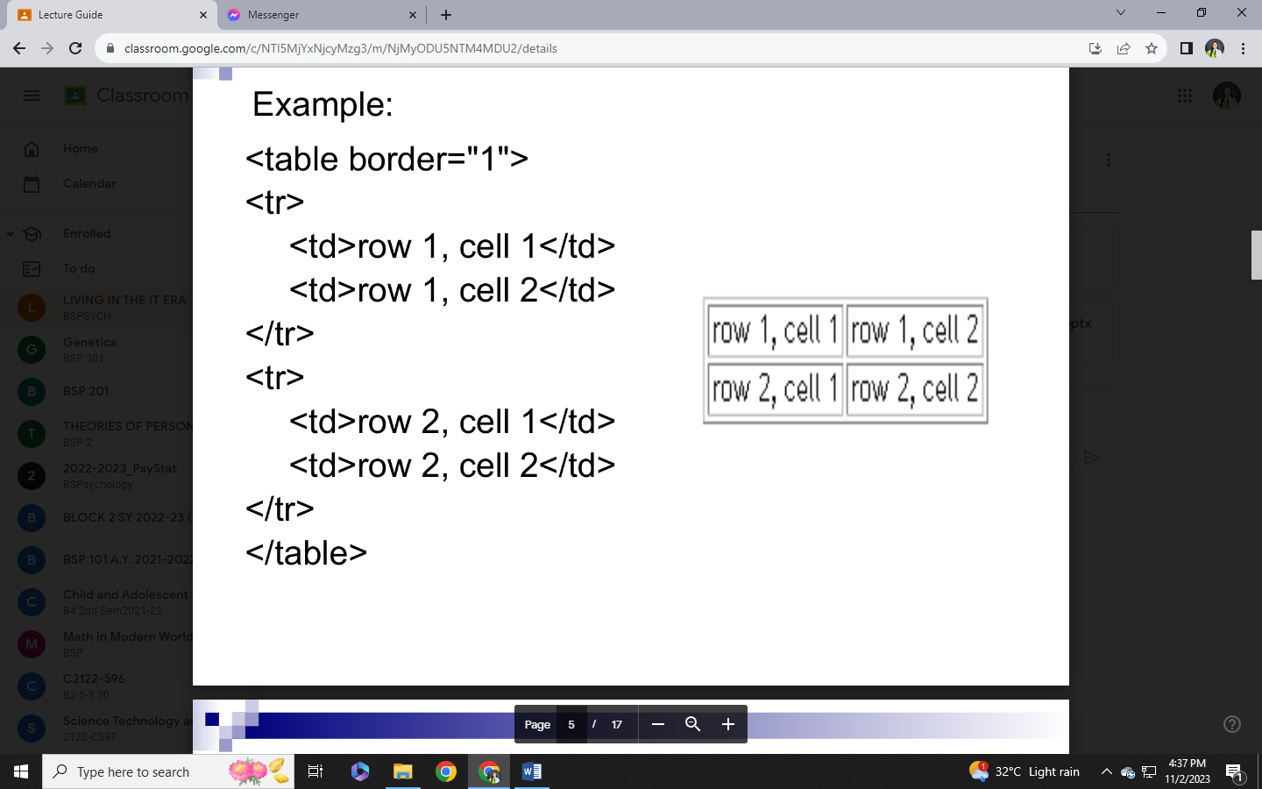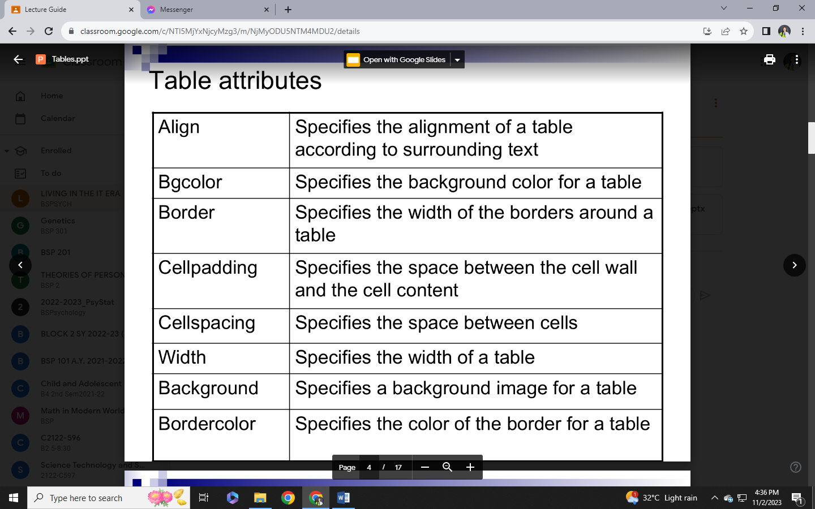

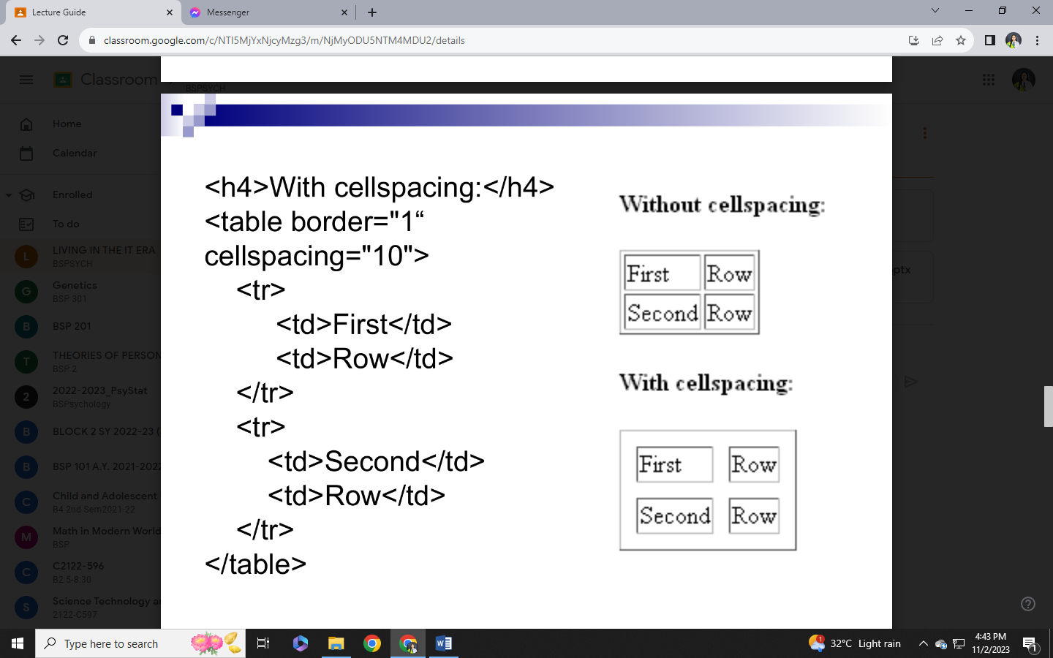Colspan - Define table cells that span more than one column.

Rowspan - Define table cells that span more than one row.

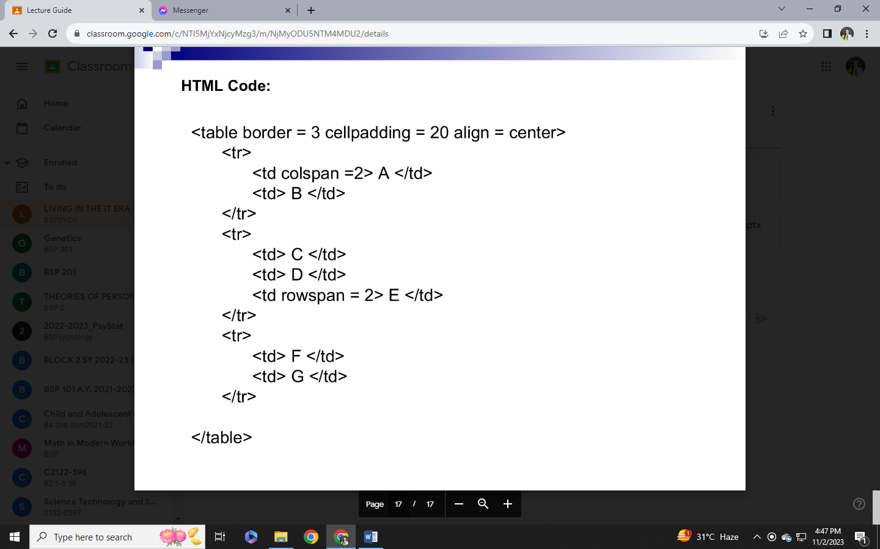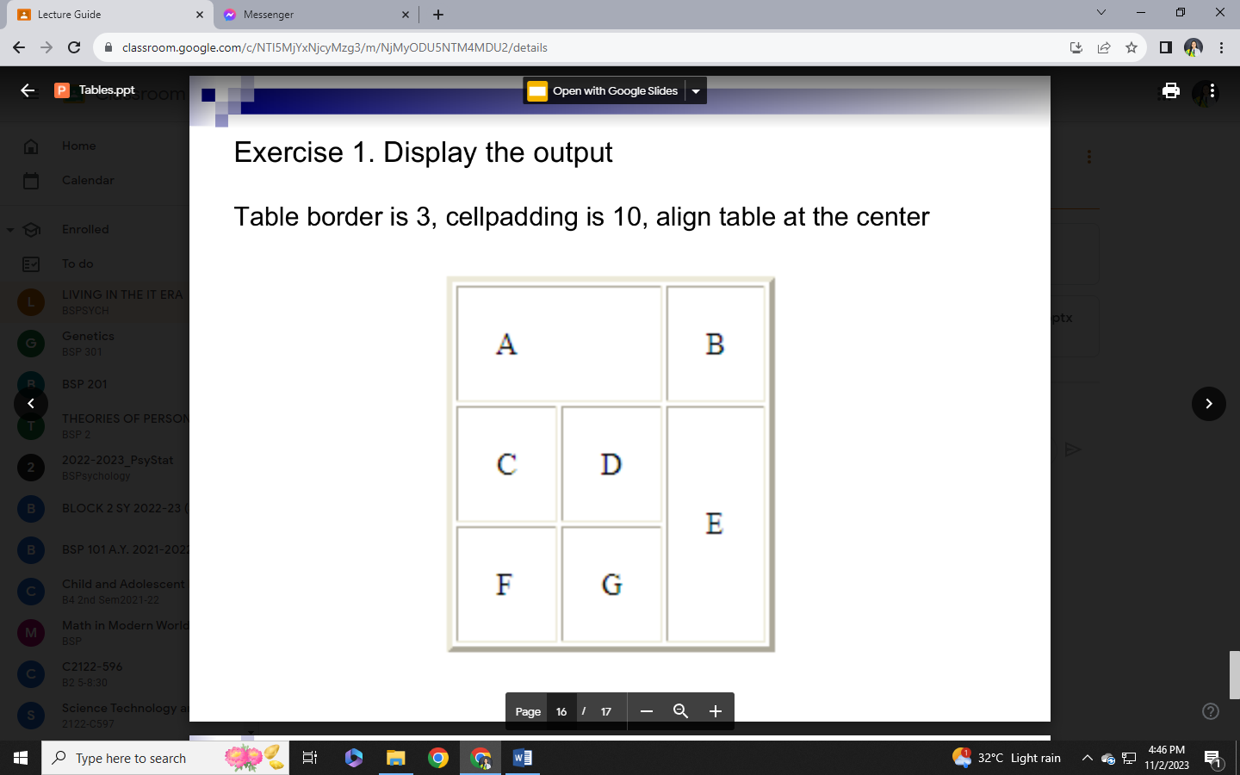Align - Specifies alignment of data in a cell.

